Attention: Chairman of the Management Committee of the Libyan Chamber of Shipping

Greetings,
Based on the decision of the Prime Minister No. (431) of 2023 approving the minutes of the award and permission to contract with Webb Fontaine regarding the electronic tracking and follow-up system for shipments to Libya.
Our letter No. (HJ/62/7747 dated 24/07/2024 AD) regarding the launch of the pre-registration system for shipment data in its experimental phase on 07/30/2024 AD, and preparations for the launch of the mandatory phase and the entry into force of the system.
Given the effective role played by maritime lines, their shipping agents or their legal representatives in ensuring the efficient and smooth implementation of this system.
Accordingly, we are forwarding to you a letter addressed to the shipping lines after presenting it to the agents of these major shipping lines operating in Libya and holding several meetings therewith. It was agreed to present it in its final form, a photocopy of which has been forwarded to you, including the following:

- Flowchart of Libya ACI System Requirements and Procedures:

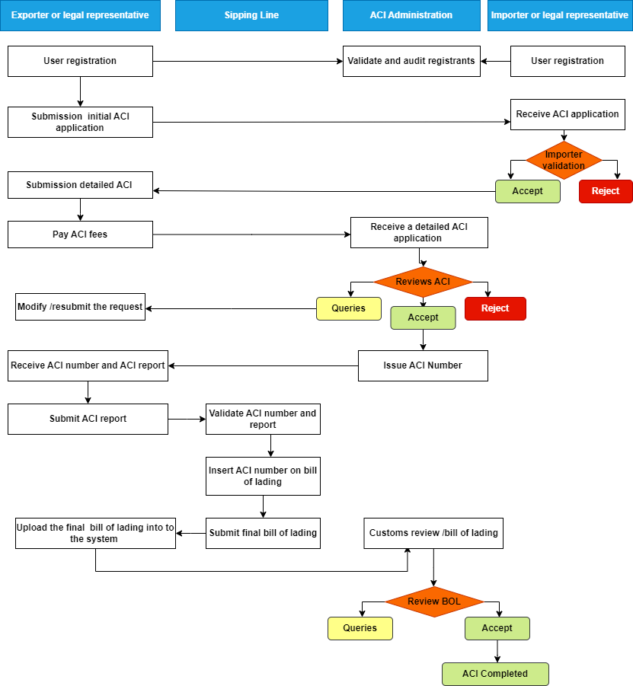

- Description of the phases of the ACI Libya ACI System requirements and procedures cycle:
- User registration: Importers and exporters or their legal representatives register through the website aci.customs.gov.ly and obtain the username and password after validation and auditing of the registrants by the ACI system administration.
- Initial ACI Application by the Exporter:
- The exporter logs into the system using the username and password and creates an initial ACI application by inserting its tax number, the statistical code of the importer and the country of export. The system automatically shows the data of the exporter and the importer with the user database.
- The exporter uploads the commercial invoice to the system and sends an initial ACI application to the importer
- Validation and acceptance of ACI application by the importer: Upon receiving the ACI application, the importer validates the listed data and the commercial invoice and gives its approval automatically through the system
- Submit a detailed ACI application: After receiving the importer's approval, the exporter shall request a detailed ACI and include includes the shipment data related to the invoice value, transportation, chapters (tariff items), goods statement, container numbers, uploads the mandatory documents such as the certificate of origin and packing list and sends the ACI application after paying the required fees.
- ACI System Administration Approval and Report Issuance: Following submission of the detailed ACI application, the ACI system administration validates and audits the accuracy of the data and documents included, and if they match and the application is approved, the system issues an ACI number that is included in a report called the “ACI Report” containing all the data of the shipment subject of the application.

- Send ACI Report to the Shipping Line: Upon issuance of the ACI report, the exporter or its legal representative shall send it to the shipping line
- Validate ACI number and report: The shipping line can validate the accuracy of the ACI number included in the ACI report via the ACI Libya System via the following link:
Aci.customs.gov.ly/aci-validator, knowing that the shipping line has no legal responsibility for the validity of the data included in the ACI report.
- Loading and Shipping of Goods: The shipping line ships and transports the goods.
- Insert ACI Number on Bill of Lading: The shipping line shall include the ACI number included in the report in the final bill of lading and send it to the exporter or legal representative.
- Upload Bill of Lading on the system:
Upon receiving the bill of lading, which includes the ACI number, the exporter logs into the system and uploads the final bill of lading to the system to be reviewed by the ACI system for approval.
- Procedures binding on shipping lines, their agents or legal representatives
All shipping lines, their agents or their legal representatives shall comply with the procedures of the ACI Libya during the trial period for sea imports and FCL containerized shipments, excluding personal luggage imported by individuals, with the remaining types of shipping units to be included gradually. You will be notified of all updates and new functions, knowing that the mandatory launch of the system is expected on November 01, 2024.
The procedures binding on shipping lines, their agents or their legal representatives are:
- It is prohibited to transport or ship goods to the Libyan State without obtaining an ACI number. If this occurs, the shipping line, its agent or its legal representative is obligated to re-export it and bear the resulting responsibilities.

- It is necessary to put the ACI number on the bill of lading after receiving the ACI report from the exporter or its legal representative.
- Resend the final bill of lading containing the ACI number to the exporter or its legal representative, to be uploaded to the system.
- All shipping lines, their agents or their legal representatives can contact the Libyan Customs Authority and submit their queries or questions via email to aci@customs.gov.ly or via email to the support center helpdesk@acilibya.ly.

- Exceptions related to the amendment of bill of lading:
Due to the existence of some exceptional cases in maritime supply operations, especially with regard to not including or changing the name of the consignee in the bill of lading according to the change of ownership of the goods supplied, or changing the last destination of the goods to the State of Libya with the change of the consignee's name, and considering that the amendment procedures in the bills of lading occur after the goods leave the port of export, which is contrary to the principle of the ACI System, this title addresses the possible exceptional cases with a description of the procedures that must be applied in parallel with the requirements of ACI Libya detailed according to the following points:
- Case 1: Bill of Lading does not include consignee name:
According to Customs Law No. (10), Chapter Three “Customs Procedures”, Chapter One “Import”, Article (61), which states that “all goods imported by sea must be registered in the general manifest of the ship’s cargo. This manifest must be signed by the captain and must include the name and nationality of the ship, the types of goods, the number of their packages, their marks and numbers, the name of the shipper and the consignee, description of the packages and the ports from which they were shipped. It is prohibited for shipping lines or their agents or their representatives to ship goods to Libya or issue bills of lading without the name of the consignee.”

- Case 2: Change consignee name
According to the Executive Regulations of the Customs Law No. (10), Part One “Import and Export Procedures”, Chapter One “Import Procedures Shipping Lists”, Article (6), the name of the importer mentioned in the shipping list can be changed based on a request submitted by the shipping agent provided that the documents supporting the validity of the name, such as invoices, documentary credit, etc., are submitted.
Considering that the consignee’s change occurs during or after the arrival of the goods, the handling of this case shall be as follows:
- Hypothesis 1: Change of consignee name on or after arrival of goods at Libyan ports
The ACI Libya procedural cycle set out in the second point of the letter (Description of the stages of the cycle of requirements and procedures of the ACI Libya) and the procedures binding on shipping lines, their agents or their legal representatives, shall remain valid in the event of changing the name of the consignee upon or after the arrival of the goods, provided that the name of the consignee is changed in accordance with the controls of the Executive Regulations of the Customs Law No. (10).
After customs clearance of the goods, the ACI application related to the shipment can be accessed and the amended bill of lading can be uploaded to the system in addition to the customs declaration.
- Hypothesis 2: Change the name of the consignee before the goods arrive at Libyan ports,
Considering that before the shipment left the exporting country, an ACI request was made, and a number and report were issued that included the name of the exporter and the name of the first consignee who was included in the first bill of lading, and considering that during the journey and before arriving in the importing country, Libya, the ownership of the goods was changed to another consignee with an amendment to the bill of lading, the system will later enable an amendment to be made to the first ACI request,

whereby the shipment and transportation of the goods was permitted by issuing an amended ACI request that includes all data related to the shipment and the name of the amended consignee.
We would like to inform you that the necessary updates in this area will be made to the system as soon as possible and you will be notified at that time, provided that the procedure stated in the first hypothesis is implemented during the trial period until the necessary updates are completed before the system is launched in a mandatory manner.

- Case 3: Change the country of destination to Libya (goods sold at sea) with the name of the consignee changed after the shipment exits the country of export:
This is an exceptional case of shipments leaving the country of export for an importer who is in another country or whose destination is not specified, and then the destination is changed for another consignee who is in Libya.
In this case, it is divided into two hypotheses: -
Hypothesis 1:
Goods that left the country of export for the benefit of an importer located in another country and then changed their destination for the benefit of a consignee located in Libya. Considering that the process of changing the consignor and consignee is considered another commercial process and independent of the first process, the first importer must log into the system and register as an exporter or legal representative of the exporter and communicate with the consignee in Libya (the importer) while following all the stages described in the flow chart of the requirements and procedures of the ACI System, provided that the ACI report is obtained 72 hours before the shipment arrives.

Hypothesis 2:
Shipments leaving the country of export without a specified destination and then the destination is changed to benefit a consignee located in Libya. The exporter must log into the system in its capacity as an exporter or legal representative of the exporter and communicate with the consignee in Libya (the importer) while following all the stages described in the graph of the cycle of requirements and procedures of the ACI System, provided that the ACI report is obtained 72 hours before the shipment arrives.
Accordingly, the procedures cycle of the ACI System in its current form can be adopted for this type of supply operations, while ensuring the implementation of the procedures binding on shipping lines, their agents, or legal representatives, as set out in point No. (03) of this letter.
This prompted us to address to clarify and inform your shipping agents to take their actions and notify shippers and lines to use ACI system of the Customs Authority as required by the public interest.
Peace be upon you!

